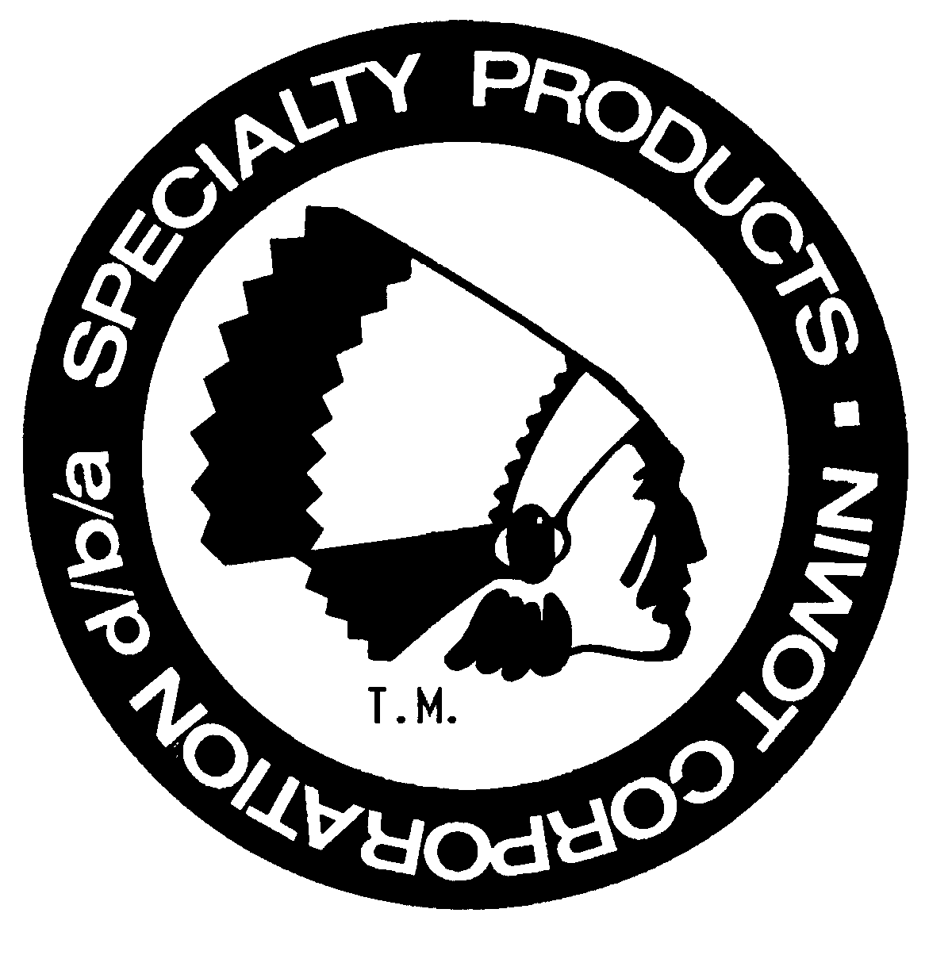
Specialty Products Company Job Opening
Mechanical Engineer
Specialty Products is a GROWING Company (www.specprod.com). We pioneered the alignment parts business in 1971 and is the preferred brand by professional installers. Our company is an aftermarket and OEM automotive supplier known for its' innovative quality products.
Specialty Products Company is currently seeking a full-time Manufacturing Engineer. See job duties below.
Summary: Responsible for the development, design, and testing for quality automotive suspension and alignment parts and tools.
IV. Roles & Responsibilities:
- Development of new product designs and/or applications
  - Assess applications and analyze/benchmark OEM components
  - Design, develop, and test components as needed
- Apply new design, process, materials or testing methods
- Create new and maintain existing engineering models and drawings
- Assemble, install and evaluate prototypes
- Create and maintain test records, test data, photo documentation, etc.
- Provide technical support to Purchasing, Quality, Manufacturing, Sales, and Customer Service
- Generate technical content for product instructions, FAQs, and marketing information
- Assist with updates to product application guide
- Continuous improvement – stays current on automotive related technology, processes, new vehicle models, engineering tools and resources, materials advances, manufacturing methods, etc.

V. General Requirements:
- BS in Mechanical Engineering (‘4-year’ program) preferred or 8 years of experience
- 1+ years professional engineering design experience in automotive industry preferred
(Must have evidence of significant personal automotive mechanical activity if not in auto industry)
- Demonstrable knowledge of automobiles, with emphasis on suspension/chassis components and function across new and old platforms
- Working knowledge of alignment principals and methods
- Working knowledge of engineering software
  - CAD - SolidWorks, PDM Enterprise and Simulation
  - Office - Word, Excel, PowerPoint
  - Not required, but a plus: Data acquisition and controls – Labview, C/C++, etc.
- Must have strong communication skills (oral and written)
- Operating knowledge of drawing standards, GD&T, tolerance stacking, etc.
- Operating knowledge of metalworking processes including machining, forging, casting, stamping/bending, etc. and familiarity with DFMA (Design For Manufacturing and Assembly) principals
- Strong attention to detail and adherence to company standards

VI. Physical Demands: While performing the duties of this job, the employee is regularly required to work at a computer for up to 8-10 hours a day, use hands to finger, handle, or feel; reach with hands and arms; talk or hear. The employee frequently is required to walk and is occasionally required to stand, climb or balance, stoop, kneel and crouch. The employee must regularly lift and/or move up to 50 pounds. Specific vision abilities required by this job include close vision, depth perception and ability to adjust focus.
Some days may require:
- Ability to lift up to 50lbs repetitively for periods up to 8hrs/day
- Ability to stand up to 8hrs/day
- Continual bending throughout the day

Work Environment: While performing the duties of this job, the employee frequently works near moving mechanical parts. The employee occasionally is exposed to fumes or airborne particles, toxic or caustic chemicals, risk of electrical shock and vibration. The noise level in the work environment is usually moderate but can occasionally be loud.
Mental Functions: While performing the duties of this job, the employee is regularly required to compare, analyze, communicate, copy, compute, synthesize, evaluate, use interpersonal skills, and compile. Frequently required to instruct and negotiate. Occasionally required to coordinate.
To Apply: Please submit an application and/or resume and salary history or requirements. Applications are available online @ www.specprod.com > Contact Us > Employment. Information may also be mailed to Specialty Products Company, 4045 Specialty Place, Longmont, CO. 80504 ATTN: Human Resources. NO RECRUITERS PLEASE.
Specialty Products Company is an Equal Opportunity Employer

